7Twelve Advisors, LLC | Nashville, TN | 615-341-0712 | contact@7Twelveadvisors.com | www.7Twelveadvisors.com

The 7Twelve Strategy
TM

A RECIPE FOR BUILDING A WISE PORTFOLIO

7Twelve Advisors | 2

What is 7Twelve?

7 Asset Classes
Twelve Underlying Investments
7Twelve is an equally- weighted diversified index-based balanced strategy

7Twelve is a blueprint for financial advisors looking to build a well-diversified investment strategy with a single investment. Unlike a traditional two-asset 60-40 balanced fund, the 7Twelve balanced strategy uses multiple asset classes in an effort to enhance performance and/or reduce risk.
Our balanced strategy provides investors access to non-traditional assets such as real estate, commodities, and emerging markets.
Each investment asset adds an important dimension to the portfolio because of the low correlation and behavior between them. The 7 of 7Twelve represents the suggested number of asset classes to include in your portfolio.

The Twelve represents the underlying investments

7Twelve Advisors | 3

WHYADIVERSIFIED INDEX-BASEDPORTFOLIO?

Why index-based? Active managers may not always outperform their index- based benchmarks. (See page 15.)

Most investors are under-diversified. For example, they do not own commodities or real estate despite that these two asset classes make
up over 57% of all global investable assets.* Holding these together with stocks, bonds, and cash in one inseparable portfolio helps make the world safe for non-traditional assets.

Additionally, Professors Brad M. Barber and Terrance Odean wrote, “Some investors fail to take advantage of the full benefits of diversification. Under- diversified investors might overinvest in company stock, local stocks, familiar stocks, and domestic companies. Doing so may make them feel safe, but it leaves them exposed to increased volatility in their investment returns.” Source: Handbook of the Economics of Finance, 2013.

The 7Twelve strategy seeks to provide breadth across seven core asset classes, and diversification depth within each separate fund in the portfolio.

*Stocks: World Federation of Exchanges, Jan 2018 Report, Bonds: 3Twelve™ Total Bond, Q4 2017, Real Estate: HSBC Holdings, December 2016 https://internationalservices.hsbc.com/content/dam/hsbcis/sh/HSBC_Global_Real_Estate_Report_July2017.pdf, Commodities: (gross, not
notional values) Bank for International Settlements - H1 2017 https://www.bis.org/publ/otc_hy1711.pdf, Cash: Investment Company Institute, Money Market Fund Assets, February 2018 https://www.ici.org/research/stats. All figures approximate. Source, Andy Martin.

7Twelve Advisors | 4

The 7
Asset Classes

7Twelve Advisors | 5

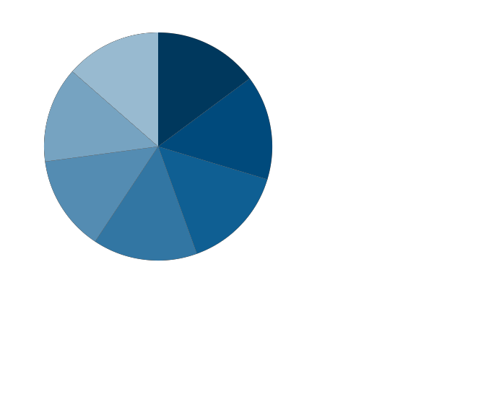

U.S. Stocks

Non U.S. Stocks

Real Estate

Cash

U.S. Bonds

Non U.S. Bonds

Commodities
WHY 7
ASSET CLASSES?

The 7Twelve strategy uses multiple asset classes to seek to enhance performance and reduce risk.

The traditional equation of two asset classes – U.S. stocks and U.S. bonds – may not add up to greater returns and less volatility.

The long-term success of the 7Twelve strategy may be the result of genuine diversification across these seven core asset classes.

7Twelve is a diversification tool for the under- diversified.

7Twelve Advisors | 6

Photography: © Lois Greenfield

The Twelve
Underlying Investments

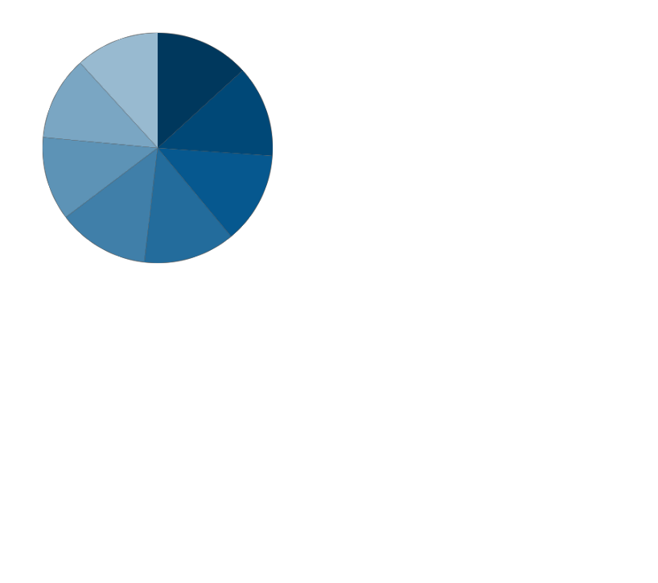7Twelve Advisors | 7

The 7Twelve strategy uses multiple asset classes: equities, fixed-income, traditional assets, and non-traditional assets. The strategy looks to invest approximately 8.3% in each asset class.

EQUITIES – 65%

U.S. STOCKS
Large Companies Medium Companies Small Companies

NON U.S. STOCKS
Developed Markets Emerging Markets

REAL ESTATE
REITS
COMMODITIES
Natural Resources Commodities

FIXED INCOME AND CASH – 35%

U.S. BONDS
TIPS
Aggregate Bonds

NON U.S. BONDS
International Bonds
CASH
U.S. Money Markets

7Twelve Advisors | 8

There are two ways to invest: predict the market, or equally- weight. Equal-weighting is the reality that we cannot effectively pick winners consistently.

7Twelve Advisors | 9

The 7Twelve strategy is an equally-weighted portfolio model

WHY EQUALLY-WEIGHT A PORFTOLIO?

If you could effectively pick winners consistently it would be settled science that market-cap weighted portfolios outperform equally-weighted portfolios.

However, the opposite is often the case. Market-cap weighted indexes have historically underperformed equally-weighted portfolios. For the 25 years ended 2018, the S&P 500 Equal Weighted Index produced an average annual return of 10.33%, vs. a 9.74% average annual total return for the market-cap weighted S&P 500 Index.
(The components of a market-cap weighted index are weighted according to their market capitalization: larger components carry larger percentage weighting. In an equally- weighted portfolio, each security is owned in equal amounts. Market capitalization is the total dollar market value of a company’s outstanding shares.)

Equal-weighting puts one important decision for you and your clients on auto- pilot and frees up your time for the decisions over which you actually have control.
An equally-weighted portfolio may be effective in today’s turbulent times. “Equal weighting’s prospects improve when forecasting is difficult, when there are lots of investment choices and when the historical learning sample is limited. That more or less describes the profile of the capital markets.”*

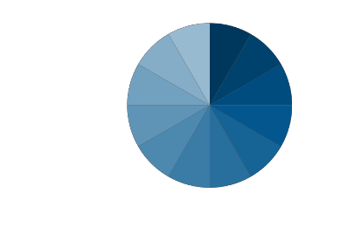
*Financial Advisor Magazine, “Model Free Investing,” December 2, 2011

7Twelve Advisors | 10

Building a
Better Balanced
Fund

7Twelve Advisors | 11

An Alpha Generation Tool?

CANAFUNDOFFUNDS GENERATEALPHA?

7Twelve may be a natural alpha generator.

How might you add alpha to a portfolio of large cap
U.S. stocks? Answer: add small cap U.S. stocks. From 1998-2018, the average annual total returns were 7.71% for U.S. small caps, vs. 4.80% for U.S. large caps.

How might you add alpha to non-U.S. bonds? Add
U.S. bonds: 3.29% vs. 4.55% annual returns respectively over the same period.

Or, add real estate, which was the number one asset class among the major seven (U.S. and non U.S. stocks and bonds, cash, real estate, and commodities) for the same period.

Or, add TIPS to aggregate bonds. From
11/30/03 - 7/31/06, when the Fed Funds rate rose by 4.25%, TIPS outperformed aggregate bonds by 4.3% annualized.

Or, add commodities, which was the #1 asset of the seven assets eleven times since 1970 through 2018, vs. seven times through 2018 for U.S. stocks.
This is how you generate alpha with a beta fund. This is also why we do not “fire” an asset just because it had a bad year. Example: the commodities sector was the worst performer for 7Twelve strategy in 2014 and for the first quarter of 2015 - but the best performer for second quarter 2015.

Past performance is no guarantee of future results. See disclosures on Page 25 for description of all indexes.

7Twelve Advisors | 12

“A wise chef follows a good recipe. Likewise, investors should have a good recipe when building a portfolio. The 7Twelve strategy may be that recipe.”

Craig Israelsen

7Twelve Advisors | 13

A Risk Management Tool

THE SECRET OF 7TWELVE? LOW CORRELATION

The 7Twelve strategy may also be used as a risk mitigation tool, as measured by low correlation. The lower the correlation, the more diversified the portfolio: the 10- year correlation (as of 5/31/19) of the twelve indexes in 7Twelve strategy was only 0.36.

4 | 0.56 | 0.79 | 0.02 |  | 5
5 | 0.40 | -0.08 | 0.02 | 0.14 |  | 6
6 | 0.19 | -0.17 | -0.06 | 0.00 | .053 |  | 7
7 | 0.16 | -0.16 | -0.07 | 0.00 | 0.53 | 0.95 |  | 8
8 | 0.30 | 0.28 | -0.03 | 0.32 | -0.33 | 0.63 | 0.69 |  | 9
9 | -0.09 | --0.18 | -0.08 | --0.01 | 0.51 | 0.90 | 0.98 | 0.68 |  | 10
10 | 0.24 | -0.16 | -0.09 | 0.06 | 0.61 | 0.88 | 0.91 | 0.58 | 0.88 |  | 11
11 | 0.32 | -0.04 | -0.02 | 0.20 | 0.59 | 0.67 | 0.68 | 0.42 | 0.63 | 0.72 |  | 12
12 | 0.38 | -0.05 | -0.05 | 0.12 | -0.61 | 0.87 | 0.85 | 0.59 | 0.79 | 0.84 | 0.79

Past performance is no guarantee of future results. When two assets are perfectly correlated, they have a correlation of 1.00, meaning their price movements react similarly to market forces. A perfectly negative correlation is -1.00, when prices move in opposite directions in response to those same forces.
1
Investment Key
1
2
2
0.54
3
3
0.05
0.05
4
- BBgBarc Global Treasury Ex US TR 7 DJ US Mid Cap TR
- BBgBarc US Agg Bond TR 8 DJ US Select REIT TR
- BBgBarc US Treasury Bill 1-3 Mon TR 9 DJ US Small Cap TR
- BBgBarc US Treasury US TIPS TR 10 MSCI USA IMI/Materials NR
- Bloomberg Commodity TR 11 Morningstar MSCI Emerging Markets
- DJ US Large Cap TR 12 S&P Developed Ex US BMI TR

7Twelve Advisors | 14
A Tool for Passive Management

7Twelve Advisors | 15

The only thing worse than active management… is active management designed simply to placate and manipulate inexperienced investors and advisors.

WHY PASSIVE MANAGEMENT?

Passive outperformed active over the short and long-terms.

According to Standard & Poor’s, 64.49% of large-cap fund managers under- performed their benchmark in 2018. Over 5- and 10- year periods ended 2018, 82.14% and 85.14%,
respectively, of large-cap managers failed to deliver incremental returns over their benchmark. In
2018, passive funds saw inflows of $207 billion, while active funds saw a
$174 billion outflow. (Source: Morningstar, Inc.)

As of December 2018:
Percentage of Active U.S. Equity Funds Outperformed by Benchmarks

Category | 1 Year | 5 Years | 10 Years
Large Cap Funds | 64.49% | 82.14% | 85.14%
Mid Cap Funds | 45.64% | 79.88% | 88.03%
Small Cap Funds | 68.45% | 89.40% | 85.67%
Source: SPIVA U.S. Scorecard

We are committed passive investors. We say no to an industry where the long-term is measured in weeks and months - rather than in decades.

7Twelve Advisors | 16

A Balance
of Risk and Reward

7Twelve Advisors | 17

A Tool for Higher Potential Reward with Less Risk

WHAT IS YOUR “REWARD DIFFERENTIAL”?

This table shows what we call the reward differential (risk - return) of six major investment categories for the 49 years ended 2018.

How did the 7 Assets do?

With an average annual total return of 8.86% vs. a risk measurement of 8.46%, the net return was more than its standard deviation.
Reward Differential 1970 – 2018
Average Annual Total Returns - Risk Taken to Achieve Returns

 | US Stocks |  |  | Non-US Bonds | 60/40 |  | Moderate Allocation |  | 7 Assets Equally-Weighted |  | US Bonds
Return | 10.31% |  |  | 7.84% | 9.38% |  | 8.83% |  | 8.86% |  | 7.11%
- Risk | 16.91% |  |  | 10.23% | 11.01% |  | 9.02% |  | 8.46% |  | 6.60%
= Reward Differential | -6.60% | -2.39% | -1.63% | -0.19% |  | 0.40% |  | 0.51%

Reward Differential is the marginal return or loss generated by an equal amount of added risk. We believe, long-term investors should seek to maximize their reward differential.

Past performance is no guarantee of future results. See disclosures on Page 25 for description of all indexes. Risk is measured by standard deviation.
Moderate Allocation: Morningstar Mgr Benchmark Moderate Allocation EW,60/40: 60% S&P 500,40% BBgBarclays U.S. Agg. All returns are indexes. Indexes are not investable. Returns do not represent those of any investment product.

7Twelve Advisors | 18

“In baseball, winning is
better than losing. In investing, not losing is better than winning.”

Andy Martin

7Twelve Advisors | 19

Performance Comparisons

Shown below are the average annual total returns for the 15-years ended 2018 for the twelve asset classes in the 7Twelve strategy. Past performance, of course, cannot predict future returns.

9.12%

5.62%
8.13%
8.11%
7.70%
6.84%
5.80%

5.29%

3.86%

3.78%

2.89%

1.25%

-2.46%

US US
Real US
Natural
Developed 7Twelve
Emerging
US Bonds TIPS
Non US
US Commodities

Stocks Midcap
Stocks Smallcap
Estate
Stocks
Largecap
Resources
Markets
Strategy
Markets
Stocks
Bonds
Money Markets

See disclosures on Page 25 for description of all indexes.

7Twelve Advisors | 20

“The 7Twelve strategy integrates investment asset classes that may seem exotic. It is the diversity of the ingredients that makes the salsa taste great.”

Craig Israelsen

7Twelve Advisors | 21

A Tool for
Retirement Distribution

HOW MIGHT 7TWELVE PERFORM DURING RETIREMENT?

How might the 7Twelve strategy perform when investors take a monthly retirement check from their account?

For example, for the 20 years ended 2018, we compared the S&P 500 Index, a 60/40 balanced index, and the diversified strategy indexes, using a 5% annual withdrawal each December. Results are highlighted in the table below.
$100,000 Investment 12/31/1998, 5.00% Annual Year-end Withdrawals

Indexes | S&P 500  Index | 60/40  Balanced | Diversified  Strategy
Distributions | $223,985 | $251,967 | $335,199
Account Value 12/31/2018 | $267,480 | $270,021 | $294,061
Total Distributions + Account Value  12/31/2018 | $491,465 | $521,988 | $629,260
Average Annualized Return | 4.65% | 5.21% | 6.99%
10 Year Standard Deviation | 13.60% | 8.12% | 9.65%
Worst 3 Year Returns | -16.00% | -5.69% -6.81%
Source data: 20 years through 12/31/18. Morningstar, Inc., 60/40 Balanced: 60% S&P 500 TR, 40% BBgBarc US Agg Bond TR. Indexes in the Diversified Strategy: BBgBarc Global Treasury Ex US TR; BBgBarc US Agg Bond TR; BBgBarc US Treasury US TIPS TR; Dow Jones US Select REIT; S&P 500 TR; S&P GSCI TR; S&P MidCap 400 TR; S&P North American Natural Resources PR; MSCI USA Small Value NR; MSCI EAFE NR; Morningstar MSCI Emerging Markets; BBgBarc Short Treasury 1-3 Mon TR. 60/40 Balanced and Diversified Strategy annually rebalanced. 10-year standard deviation.

Indexes are not investable. Past performance does not guarantee future results.

7Twelve Advisors | 22

A Portfolio
of Innovation

7Twelve Advisors | 23

AN INNOVATIVE PORTFOLIO

Can a fixed portfolio of twelve assets be improved?
Yes. At 7Twelve Advisors, LLC we are constantly monitoring each of the
twelve asset classes and their underlying funds for good governance, liquidity, low internal expenses, low tracking error to the index, tight spreads between bid and ask, low correlation, optimal returns, risk management, and other criteria.

We make changes to the portfolio accordingly after an exhaustive review process.

Even strategic (passive) managers have an obligation to carefully select and manage the underlying assets.
Therefore, our job does not end with simply buying and holding twelve assets.

7Twelve Advisors | 24

About Us

7Twelve Advisors, LLC, founded in 2008, is an institutional investment management and Registered Investment Advisor firm (RIA).

Our mission is to create a fully diversified investment portfolio for institutional and individual investors, based on the multi-asset, index-based, equally weighted, global strategies of Craig Israelsen, Ph.D., and the principles of 7Twelve Advisors.
Andy Martin is Co-founder, President, and portfolio manager of 7Twelve Advisors, LLC. Mr. Martin is the author of Dollarlogic: A Six-Day Plan to Achieving Higher Returns by Conquering Risk, (foreword by Arthur B Laffer, Ph.D.) Andy earned a BBA (Economics) from Belmont University and an MLAS from Vanderbilt University. Mr.
Martin is a member of the Investment Management Consultants Association, and sits on the Investment Company Institute (ICI) Small Funds Committee.

Craig Israelsen, co-founder of 7Twelve Advisors, LLC, and creator of the 7Twelve strategy, is an Executive-in-Residence in the Financial Planning Program at Utah Valley University (UVU) in Orem, Utah. Dr. Israelsen is the author of 7Twelve: A Diversified Investment Portfolio with a Plan . He holds a Ph.D. in Family Resource Management from Brigham Young University (BYU). Primary among his research interests is the analysis of mutual funds and the design of investment portfolios.

7Twelve Advisors | 25
DISCLOSURE

7Twelve Advisors, LLC (“7Twelve”) is a registered investment advisor with the U.S. Securities and Exchange Commission. The information contained herein is for educational purposes only and is not to be considered investment advice nor a recommendation of any fund, product or investment. Information is obtained from third-party sources which are believed to be reliable, but have not been independently verified by
7Twelve.
“7Twelve” is a trademark. 7Twelve™, 7Twelve Advisors, LLC, and all strategies, models, adaptations, and products created from said intellectual property are the sole ownership of Craig Israelsen, PhD, and/or 7Twelve Advisors, LLC.

The value of small or medium capitalization company stocks may be subject to more abrupt or erratic market movements than those of larger, established companies or the market averages in general. Real estate values rise and fall in response to a variety of factors, including local, regional and national economic conditions, interest rates and tax considerations. The value of the strategy’s investments in bonds and other fixed income securities will fluctuate with changes in interest rates. Security issuers might not make payments on debt securities held by the strategy, resulting in losses.

Foreign investing involves risks not typically associated with U.S. investments, including adverse fluctuations in foreign currency values, adverse political, social and economic developments, less liquidity, greater volatility, less developed or less efficient trading markets, political instability and differing auditing and legal standards. Countries with emerging markets also may have relatively unstable governments, social and legal systems
that do not protect shareholders, economies based on only a few industries, and securities markets that trade a small number of issues.

Investing in the commodities markets through commodity-linked ETFs will subject the strategy to potentially greater volatility than traditional securities. Commodity prices are influenced by unfavorable weather, animal and plant disease, geologic and environmental factors as well as
changes in government regulation such as tariffs, embargoes or production restrictions. The strategy’s exposure to companies primarily engaged in the natural resource markets may subject the strategy to greater volatility than the securities market as a whole.

Increases in real interest rates can cause the price of inflation-protected debt securities to decrease. Interest payments on inflation- protected debt securities can be unpredictable. The cost of investing in the strategy will be higher than the cost of investing directly in ETFs and may be higher
than other mutual funds that invest directly in stocks and bonds.
Page 11,17, and 19: STOCKS: 1970-2018, S&P 500 Composite Return, NON-US STOCKS: 1970-2018 MSCI EAFE GD, Advisory World Scanalytics, US BONDS: 1970-1975, US Treasury 10-year bond at end of each year from the Federal Reserve of St. Louis (FRED), Aswath Damodaran, PhD; 1976-2018, NON-US BONDS: 1970-1980, Roger G. Ibbotson, Richard C. Carr and Anthony W. Robinson Financial Analysts Journal Vol. 38, No. 4 (Jul. - Aug., 1982), pp. 61-83 Published by: CFA Institute Article Stable URL:http:// www.jstor.org/stable/4478566; 1981-1985, Citigroup World Govt Bond-US$; 1986-2018, JP Morgan GBI Global ex-U.S. FX NY Index, REAL ESTATE: 1970-1971, 2018 7Twelve®
Portfolio Big Research Report by Craig L. Israelsen, Ph.D. (48‐Year Performance of 7 Core Asset Classes and a 7‐Asset Portfolio 1970‐2017 pg. 50), NAREIT All Reit Ix. 1972-2018, FTSE Nareit Composite, https://www.reit.com/data-research/reit-indexes/annual- index-values-returns, COMMODITIES: 1970 - 2018 S&P GSCI TR, CASH: 1970-2018, 3-Month Treasury Bill: Secondary Market Rate, Percent, Annual, Not Seasonally Adjusted, Federal Reserve Economic Data, Link: https://fred.stlouisfed.org"

“The 7Twelve Strategy” is back-tested by equal-weighting Twelve underlying indexes, funds, and ETFs which represent the asset classes. In as
much as TIPS were first traded as a security in 1998 (first full year), the only way one can model the strategy longer term (back to 1970) is to compare with the "7 Asset" strategy which is composed of US and non US Bonds and Stocks, Real Estate (REITS), Commodities, and Cash.
There has been a high correlation between the returns of the 7Twelve strategy and the 7 asset strategy, but there is no guarantee that this will continue. Indexes are not investable. No fund or securities product returns are mentioned or implied.
Past performance is no guarantee of future returns.

7Twelve Advisors | 26

For More Information

7Twelve Advisors, LLC 3100 West End Ave, Suite 930 Nashville, TN 37203

Andy Martin President 615-341-0712
amartin@7twelveadvisors.com www.7twelveadvisors.com

